.SC：

1.A 2.C 3.A 4.D 5.A 6.C 7.B 8.A 9.B 10.B 11.C 12.A 13.C 14.A 15.C

MC:

AB 17. BCD 18. B 19.A 20.C 21.BD 22.AC 23.B 24.BD 25.ACD

Question 3. (4% + 4% + 6% + 8% + 8% = 30%)

3.1) A. [9,8,7,6,5,4,3,2,1] 2 points

B. O(n2) 2 points

3.2) A. 6 2 points

B.

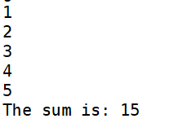 2 points

3.3)

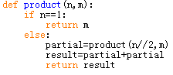

recursion:3 points

O(logn):3 points

3.4)A. 1.self.head=Node(e,self.head)

2.self.size+=1

3.answer=self.head.element

4.self.head=self.head.pointer

5.self.size-=1

6.s.push(i)

7.mid=s.pop()

B. [5,4,3,2,1]

each 1 point

3.5) A. Breadth First Search

B. O(n)

C. Multiple recursive function

D.

8

10

3

14

6

1

13

7

4

each 2 points